**EEM326E CONTROL SYSTEMS TERM PROJECT**

**Due On: 4th June 2018 – 23:59**

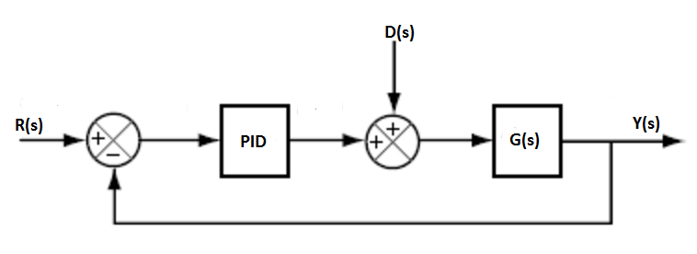

G(s) = $\frac{s+5}{(s^{2}+14s +40)}$ D(s) = 3[u(t-4) – u(t-5)]

R(s) is step input (u(t)),

1.) Using MATLAB Editor:

* Sketch the root locus for the closed loop control system and determine the range of Kp for stability (Use *rlocus* function).
* Plot the step response of the closed loop system (Use *step* and block diagram reduction functions). Assume that PID controller contains only proportional constant Kp. (Ignore D(s)).

2.) Using MATLAB SIMULINK:

* Obtain PID Controller parameters that satisfies the following properties: (Ignore D(s))
  + Settling time is less than 2 seconds,
  + Maximum overshoot is less than %6,
  + Plot the step response of the closed loop system.
* Apply disturbance, D(s), to the system. Plot the step response of the closed loop system. Discuss on the effect of the disturbance? Determine new settling time.

3.) Using MATLAB SISOTOOL:

* Design PID controller using Ziegler Nichols method. Please verify the settling time and maximum overshoot. (Ignore D(s)).